**REGISTRATION**

At first **register** yourself by going to the URL **(**<https://tathyasathi.bangla.gov.in/>)

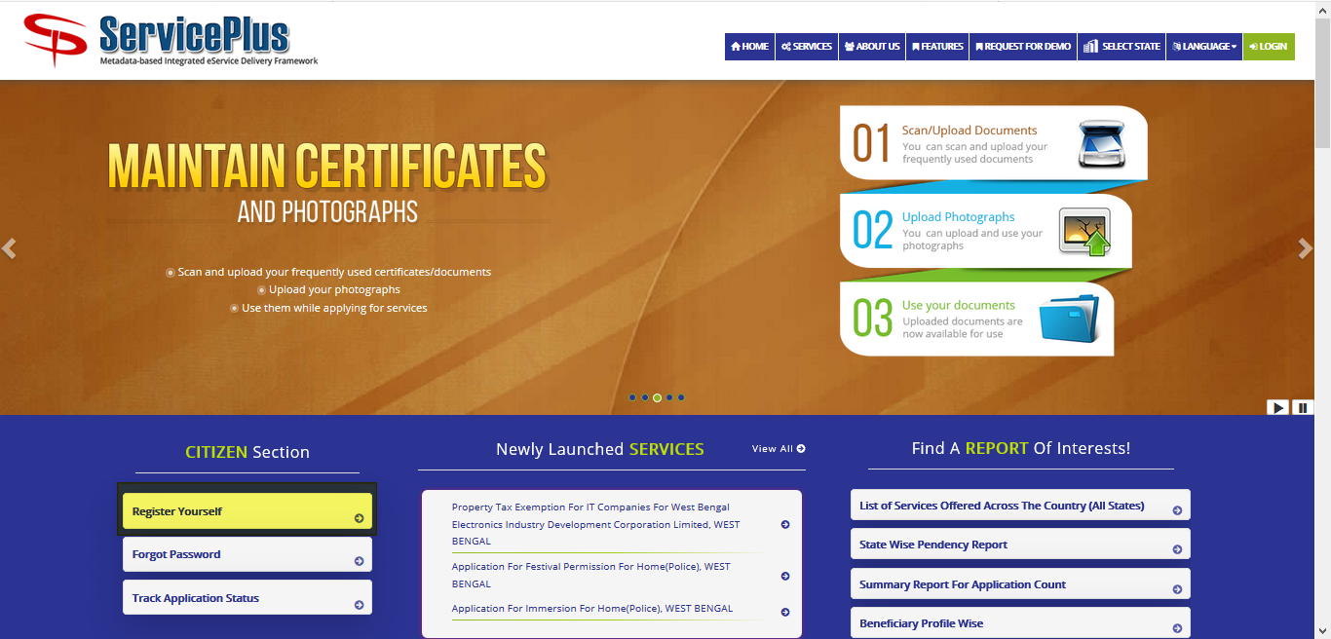

Fill in with proper **details** and **validate**.

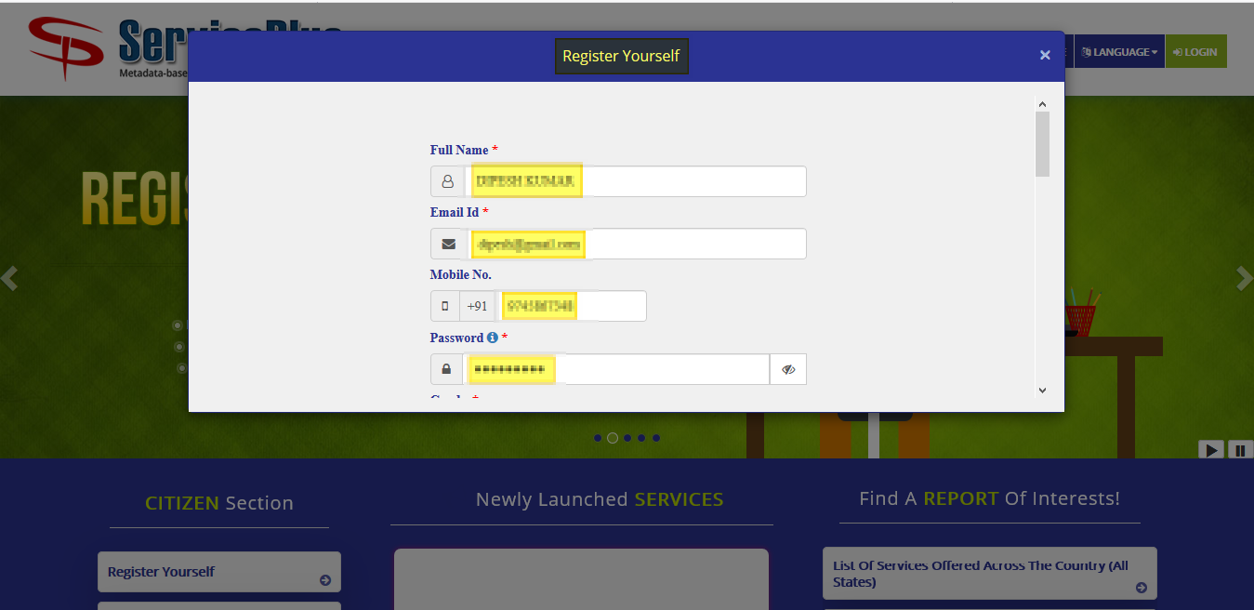

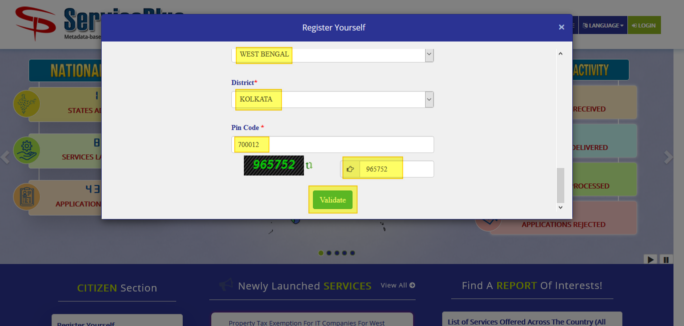

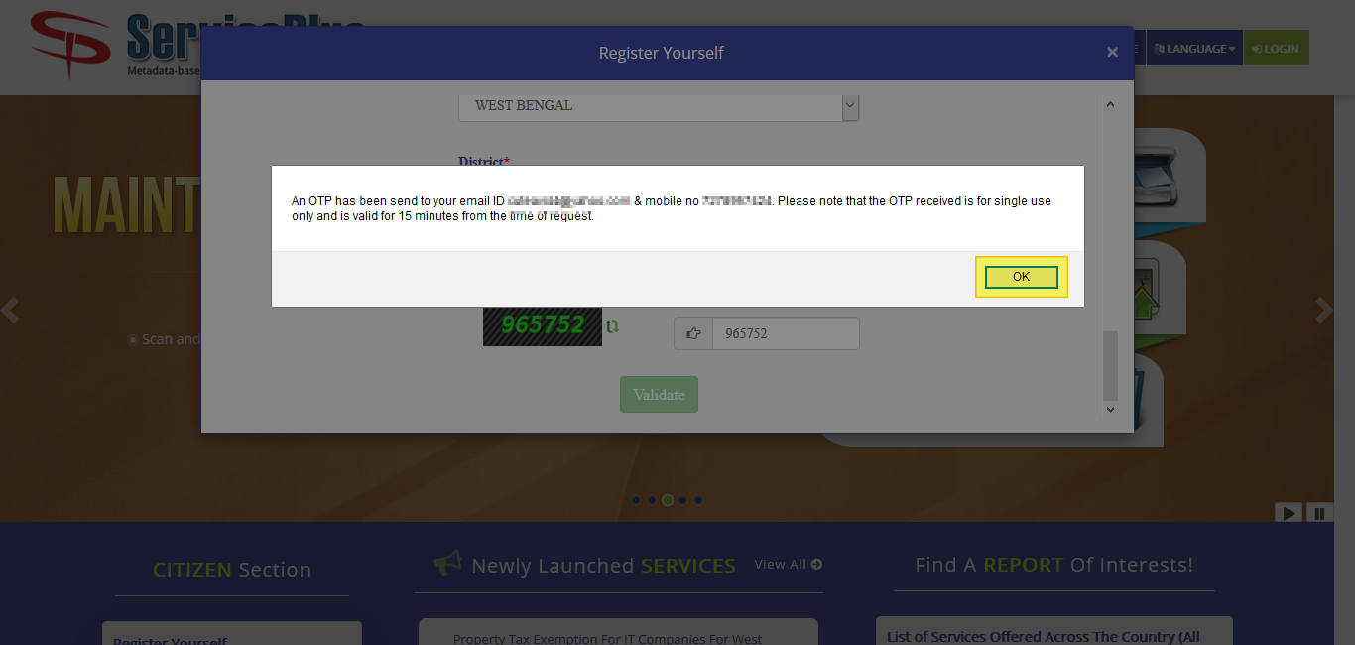

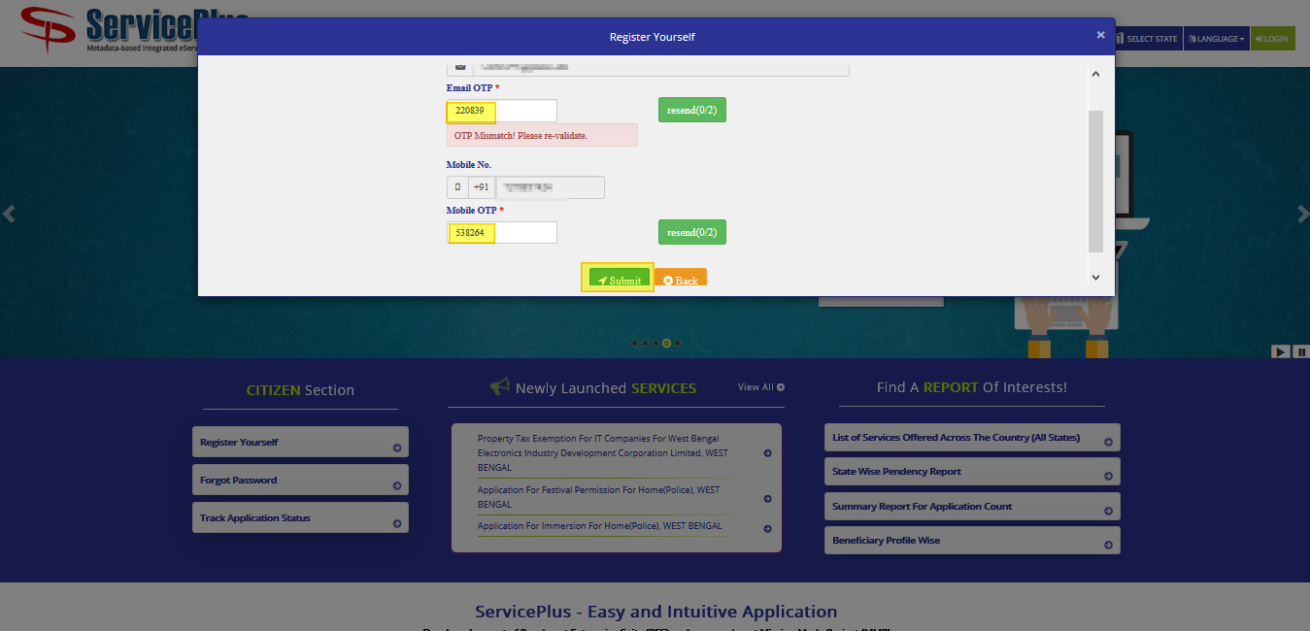

After successful registration.

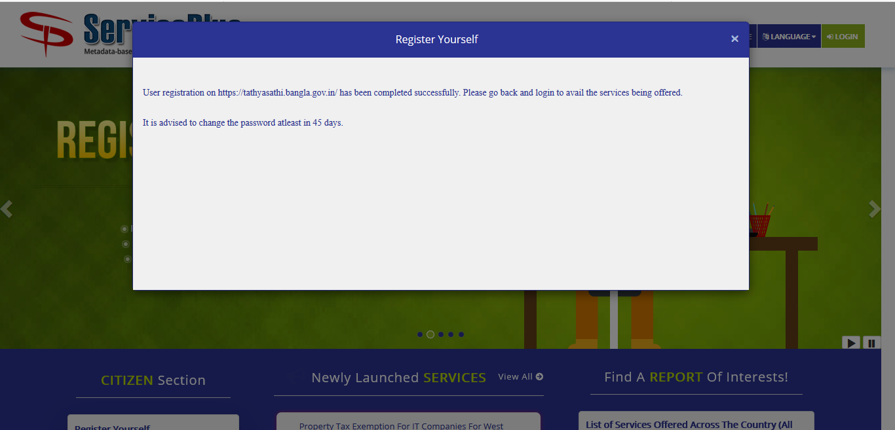

**APPLICATION PROCESS**

**STEP -1:**

At first login to Service plus web portal**: (**<https://tathyasathi.bangla.gov.in/>) to apply for the **Application for Cancellation of License.**

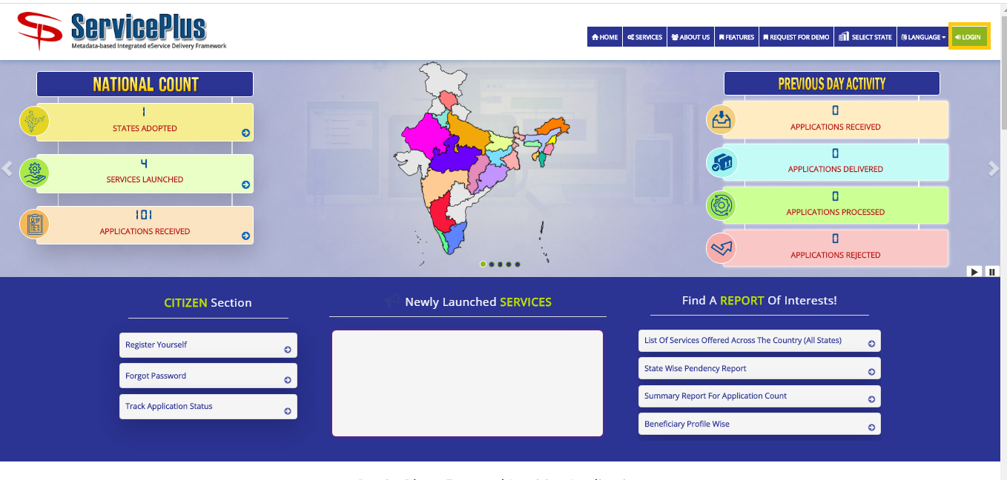

**Step -2:**

Login in the Service plus portal.

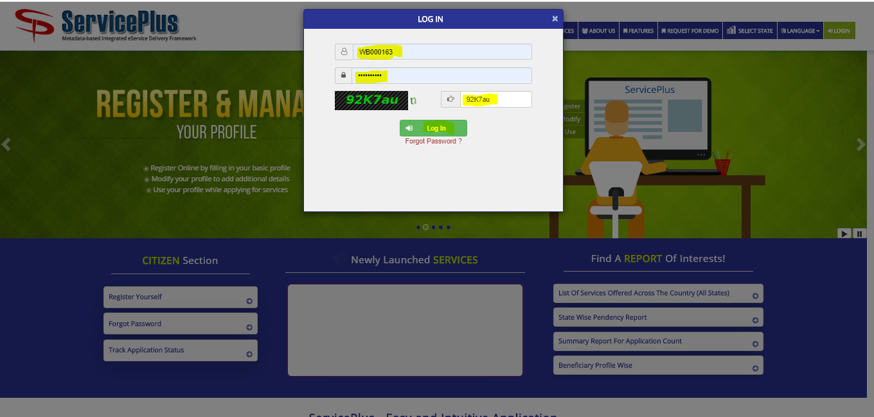

**Step -3:**

Now click “**Apply for services”** and select “**View all available services**”, then Select particular Service and Fill the form:

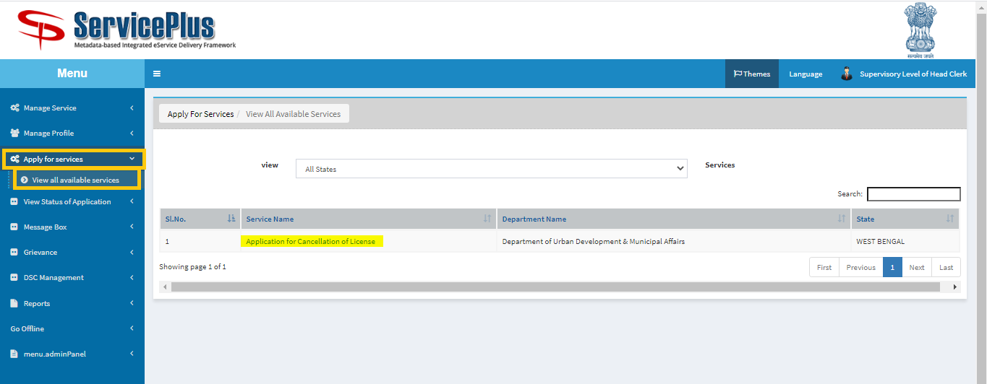

**Step -4:**

Fill the details “**Flat No**” and “**License Number**” and click **Get Data.**

Fill the form with the details as required.

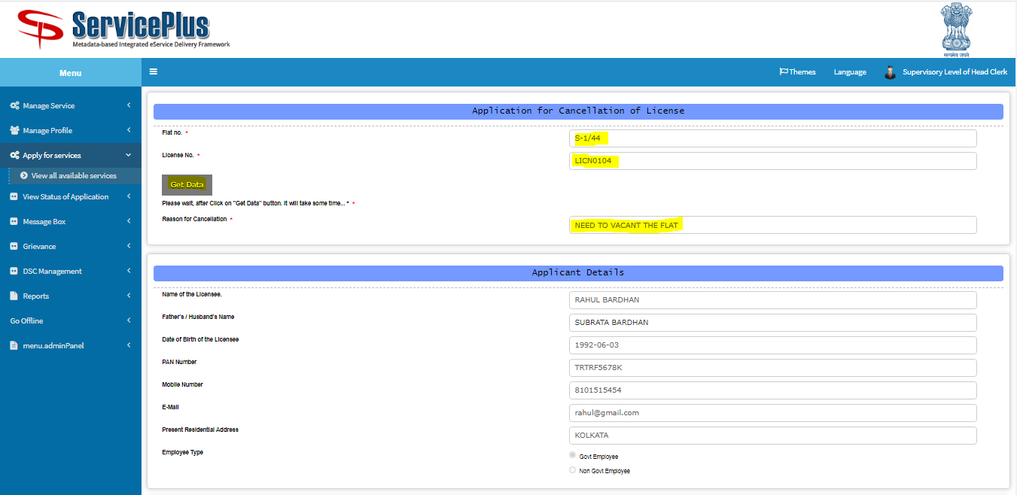

After that submit by matching the captcha.

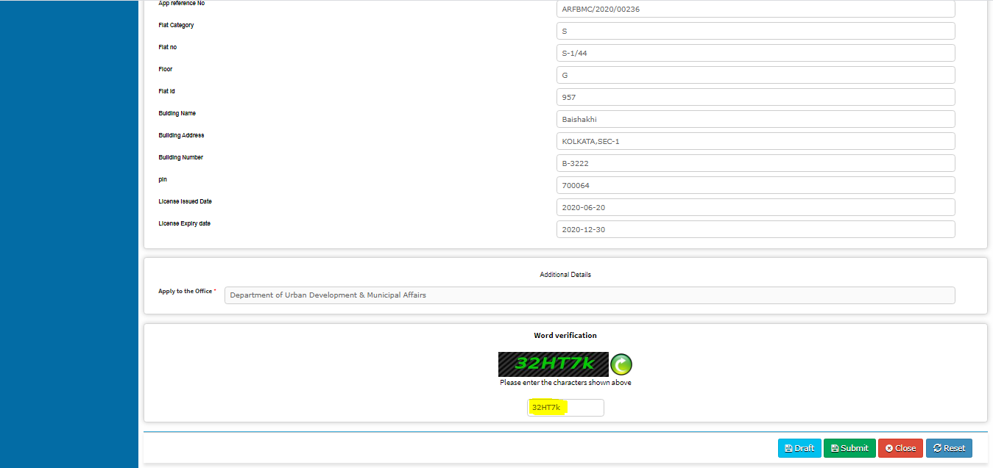

Now Click On Submit button.

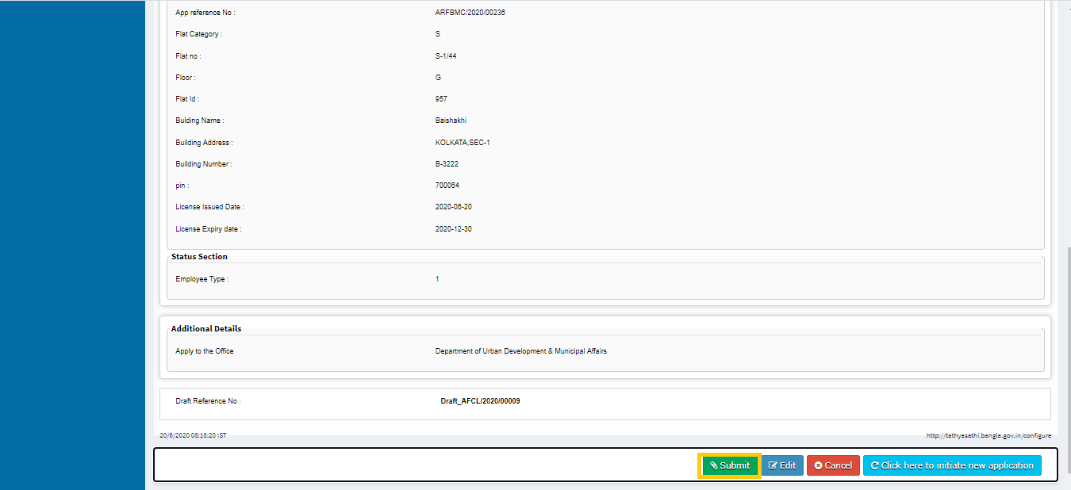

**Step -5:**

After Submission of form an acknowledgement slip is generated with **app reference number.**

Save by selecting “**Export to pdf”** or print it by selecting “**Print”**

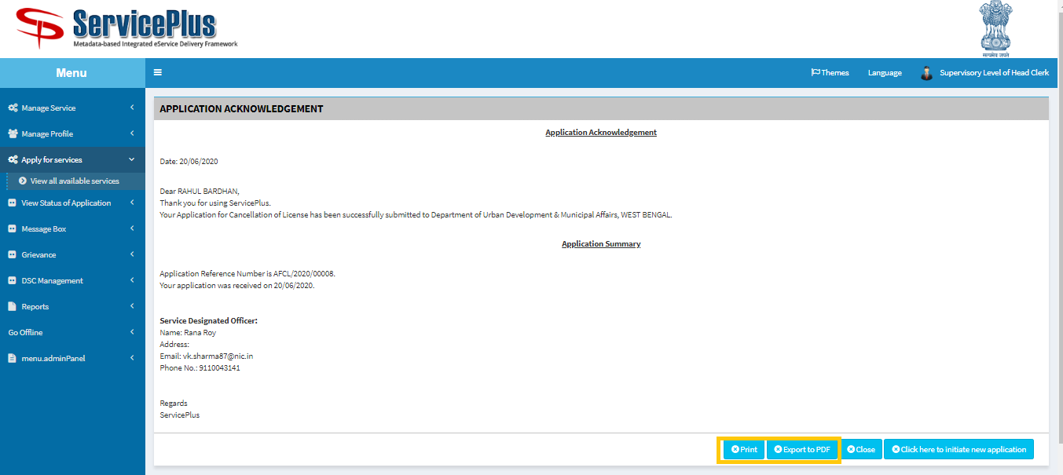

**This is the Application Acknowledgement.**

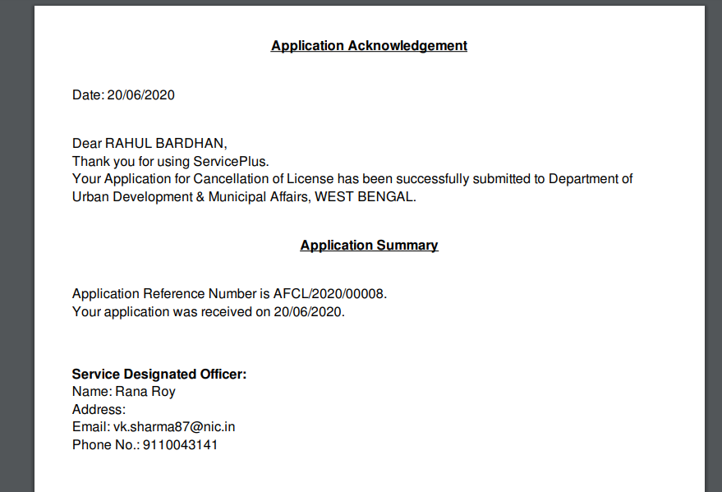

**Estate Officer (Generation of Termination Letter)**

**STEP -1:**

At first login to Service plus web portal**: (**<https://tathyasathi.bangla.gov.in/>) to apply for the **Application for Cancellation of License.**



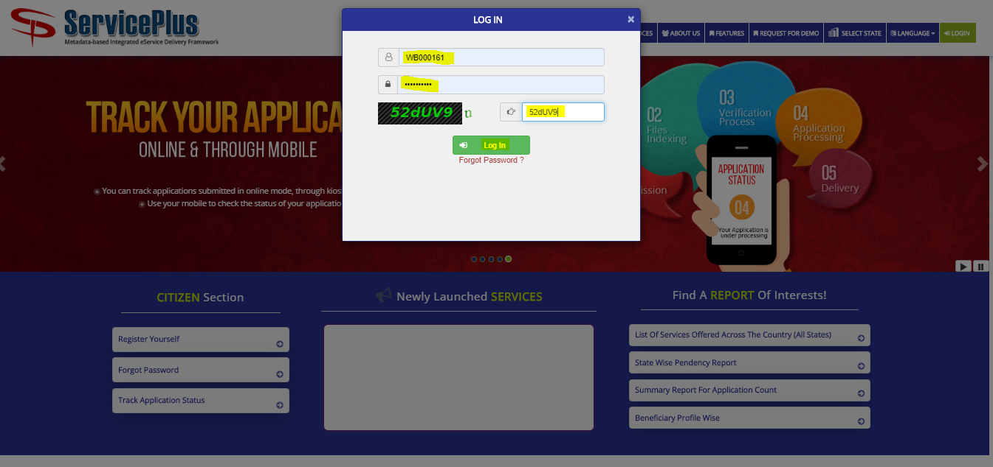

**Step 2:**

Now Go to **“Message Box”** and select **“Inbox”**.

In Inbox select the service **“Application for Cancellation of License”** and select the task **“Generation of Termination Letter by Estate Officer”** and select **“Get Data”.**

Select **“Pull”/ “Take Action”** to take action.

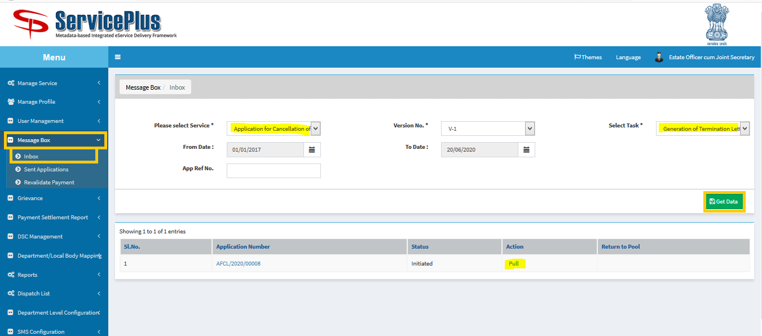

**Step 3:**

Select **“View Processing History”** to see the history of the application.

Action of the form can be taken by **Estate Officer** by taking action in two steps to **forward** and **Forward To-Estate Officer cum joint Secretary** and click on **“Cancel License”** button**.**

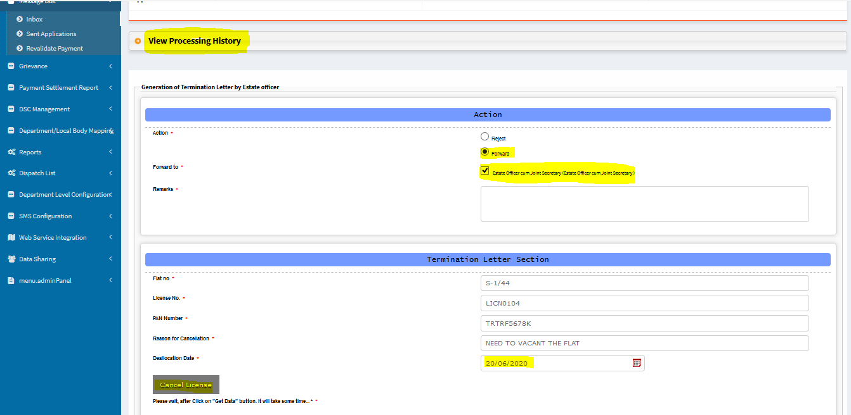

After showing success message click **“ok”** and continue

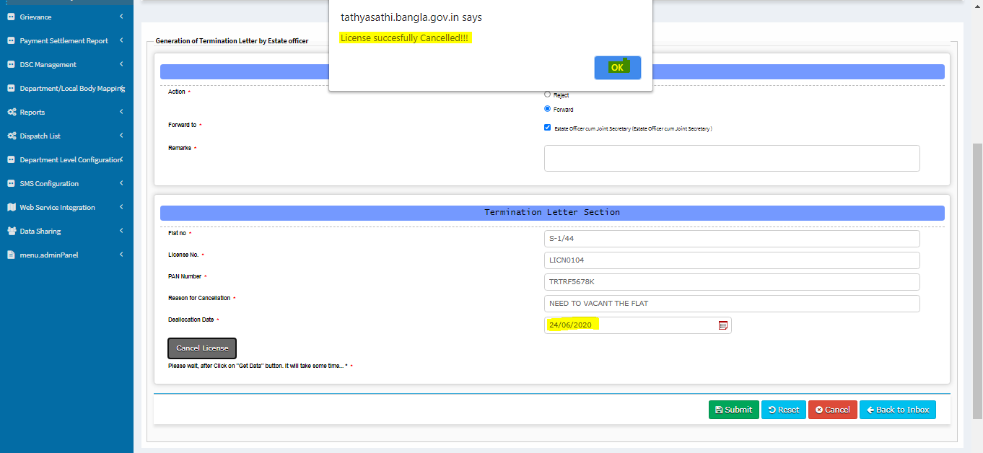

Give **Remarks** & **Submit.**

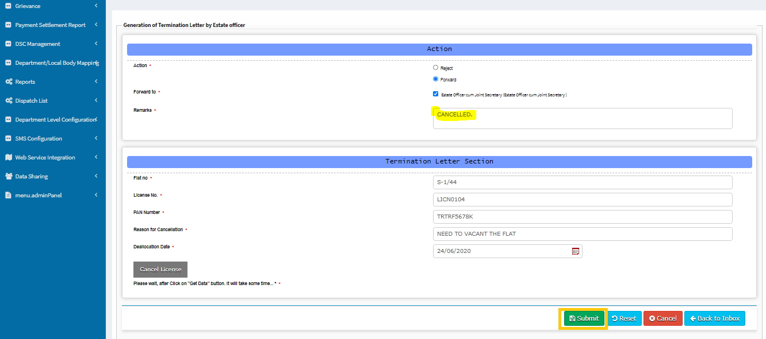

**Step 4:**

Here download file by clicking the **file** icon and **submit**.

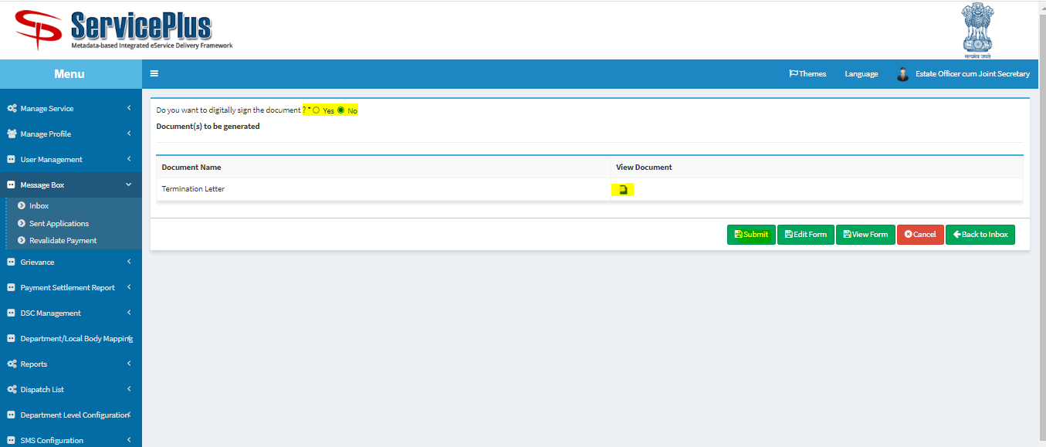

**This is the Termination Letter.**

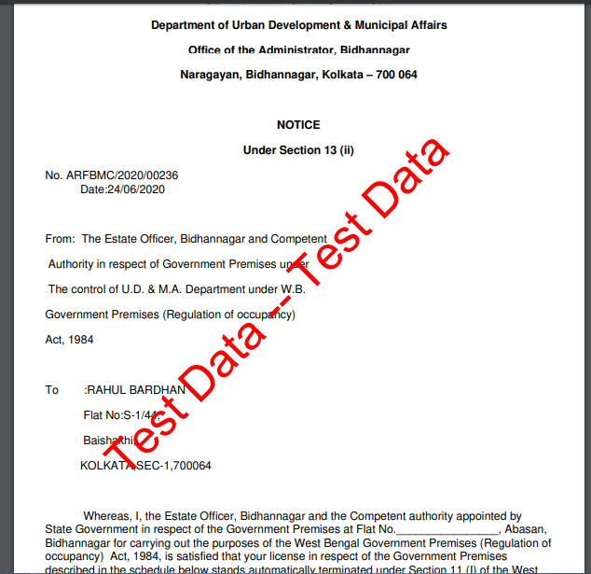

**Now the application submitted successfully.**

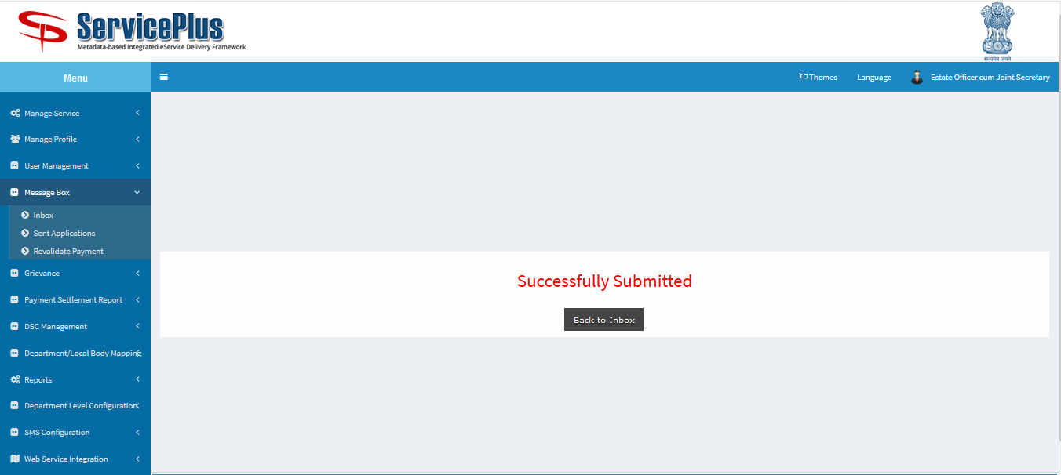

**Estate Officer (Issuance of Termination Letter)**

**Step 1:**

Again Login as **“Estate Officer**” in Service plus web portal.



**Step 2:**

Select the service **“Application for Cancellation of License”** and select the task **“Issuance of Termination Letter by Estate Officer”** and select **“Get Data”.**

Select **“Pull” / “Take Action”**.

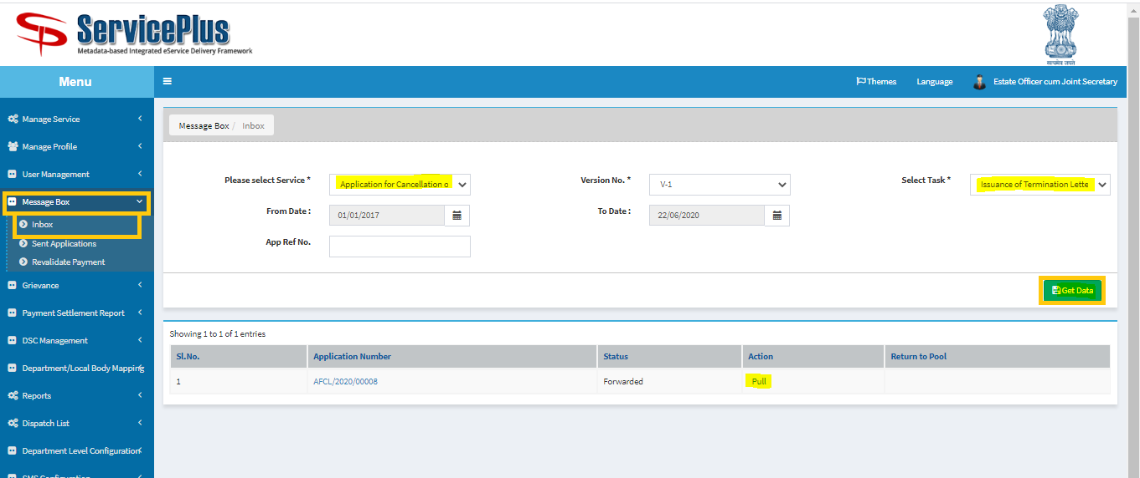

**Step 3:**

Select **“View Processing History”** to see the history of the application.

Action of the form can be taken by **Estate Officer** by taking action to **deliver.**

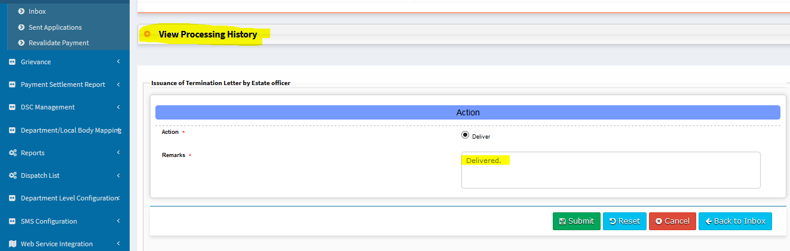

Upload The **Termination Letter** & **submit**.

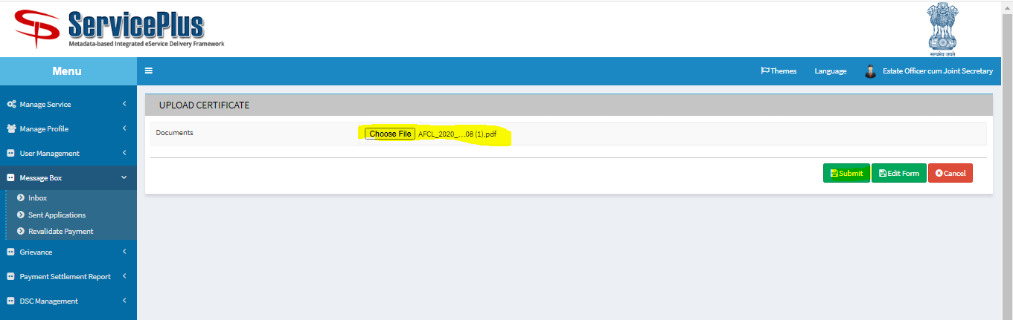

**Step 4:**

Here download file by clicking the **file** icon and **submit**.

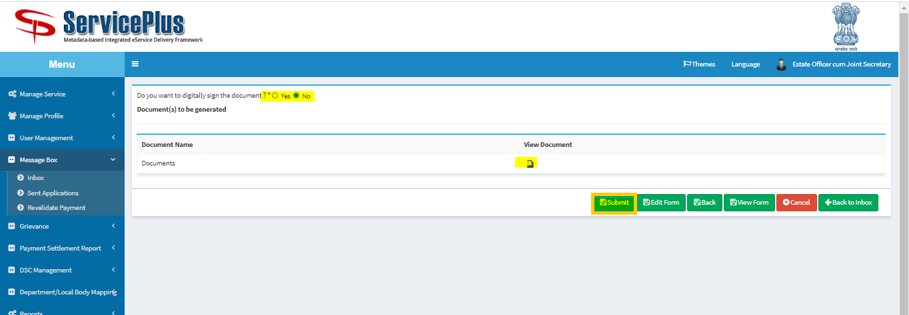

**This is the Termination Letter**



Now the application Delivered successfully.

